Machine design M3

Project number 74

Michael Hany 55-23395 T-28

This is my design

And this is the lengths of it

So for full analysis for postion ,velocity and acceleration we will have to divide it to :

1. Fourbar mechanism
2. Slider crank

First. Fourbar mechanism:

The kinematic equations using the analytical approach

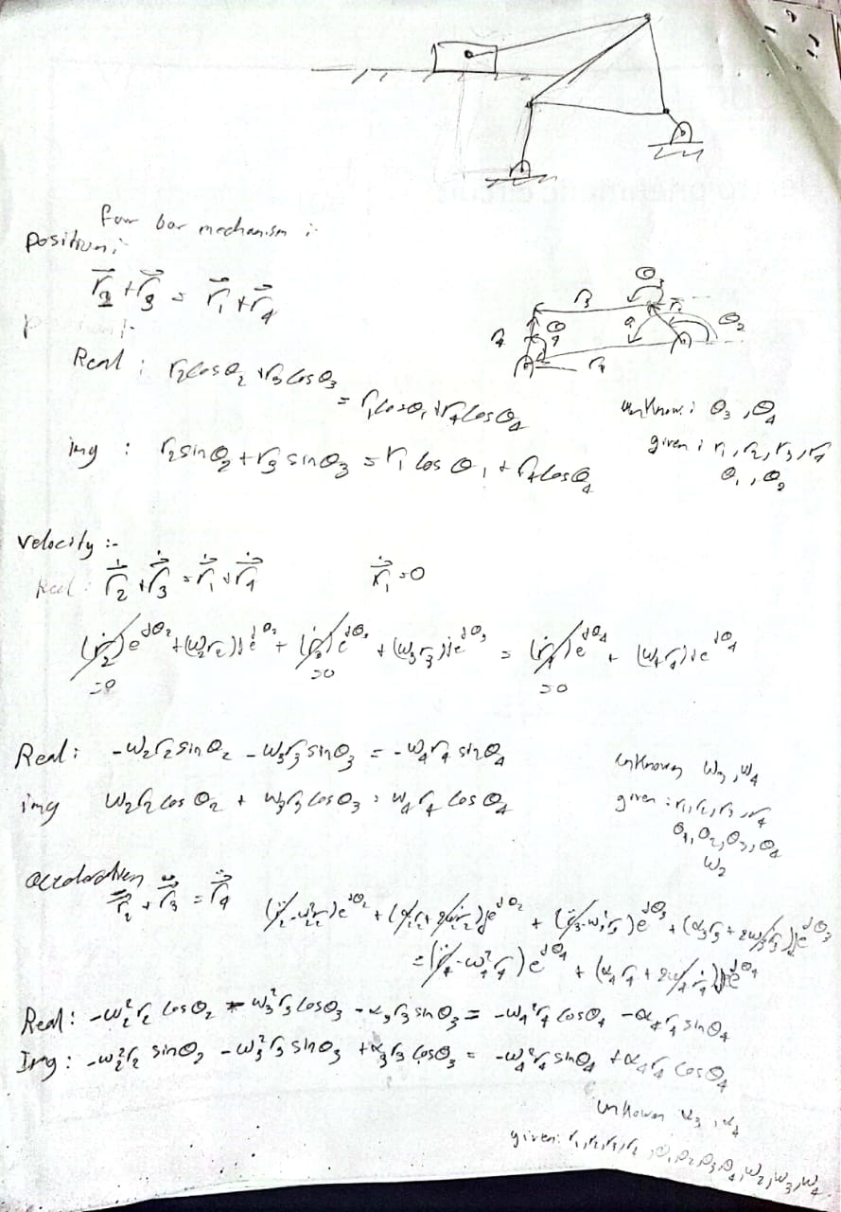

**MATLAB files and Plot graphs:**

Position:

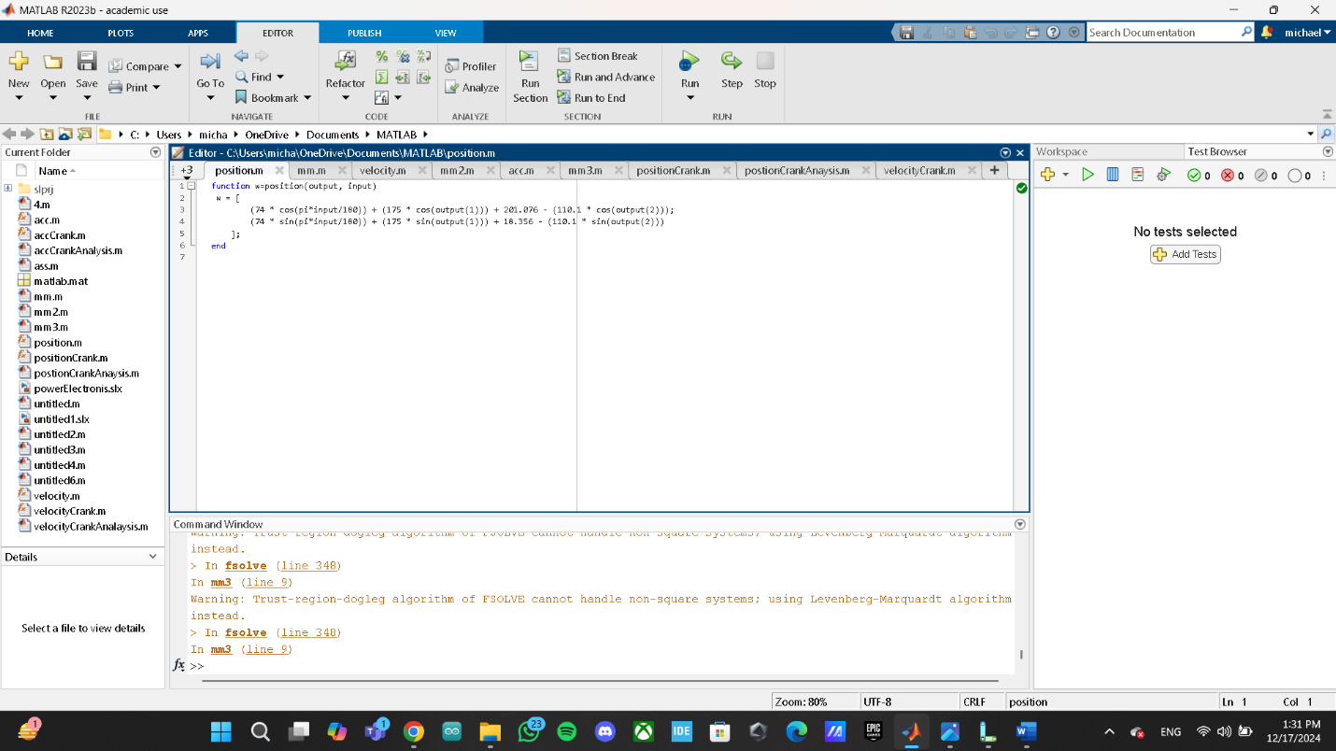

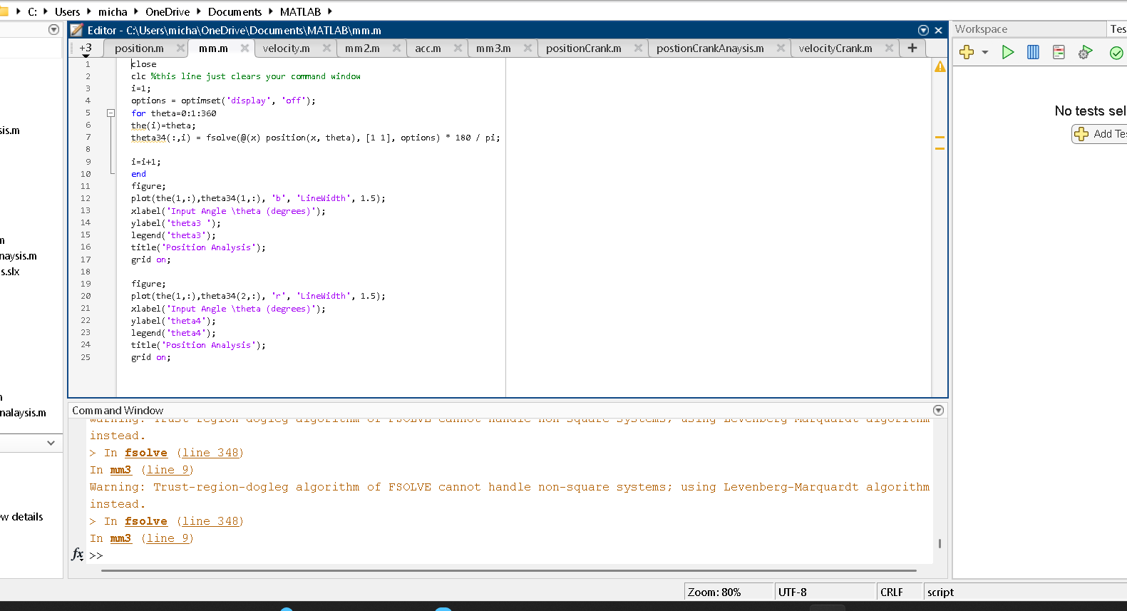

Velocity:

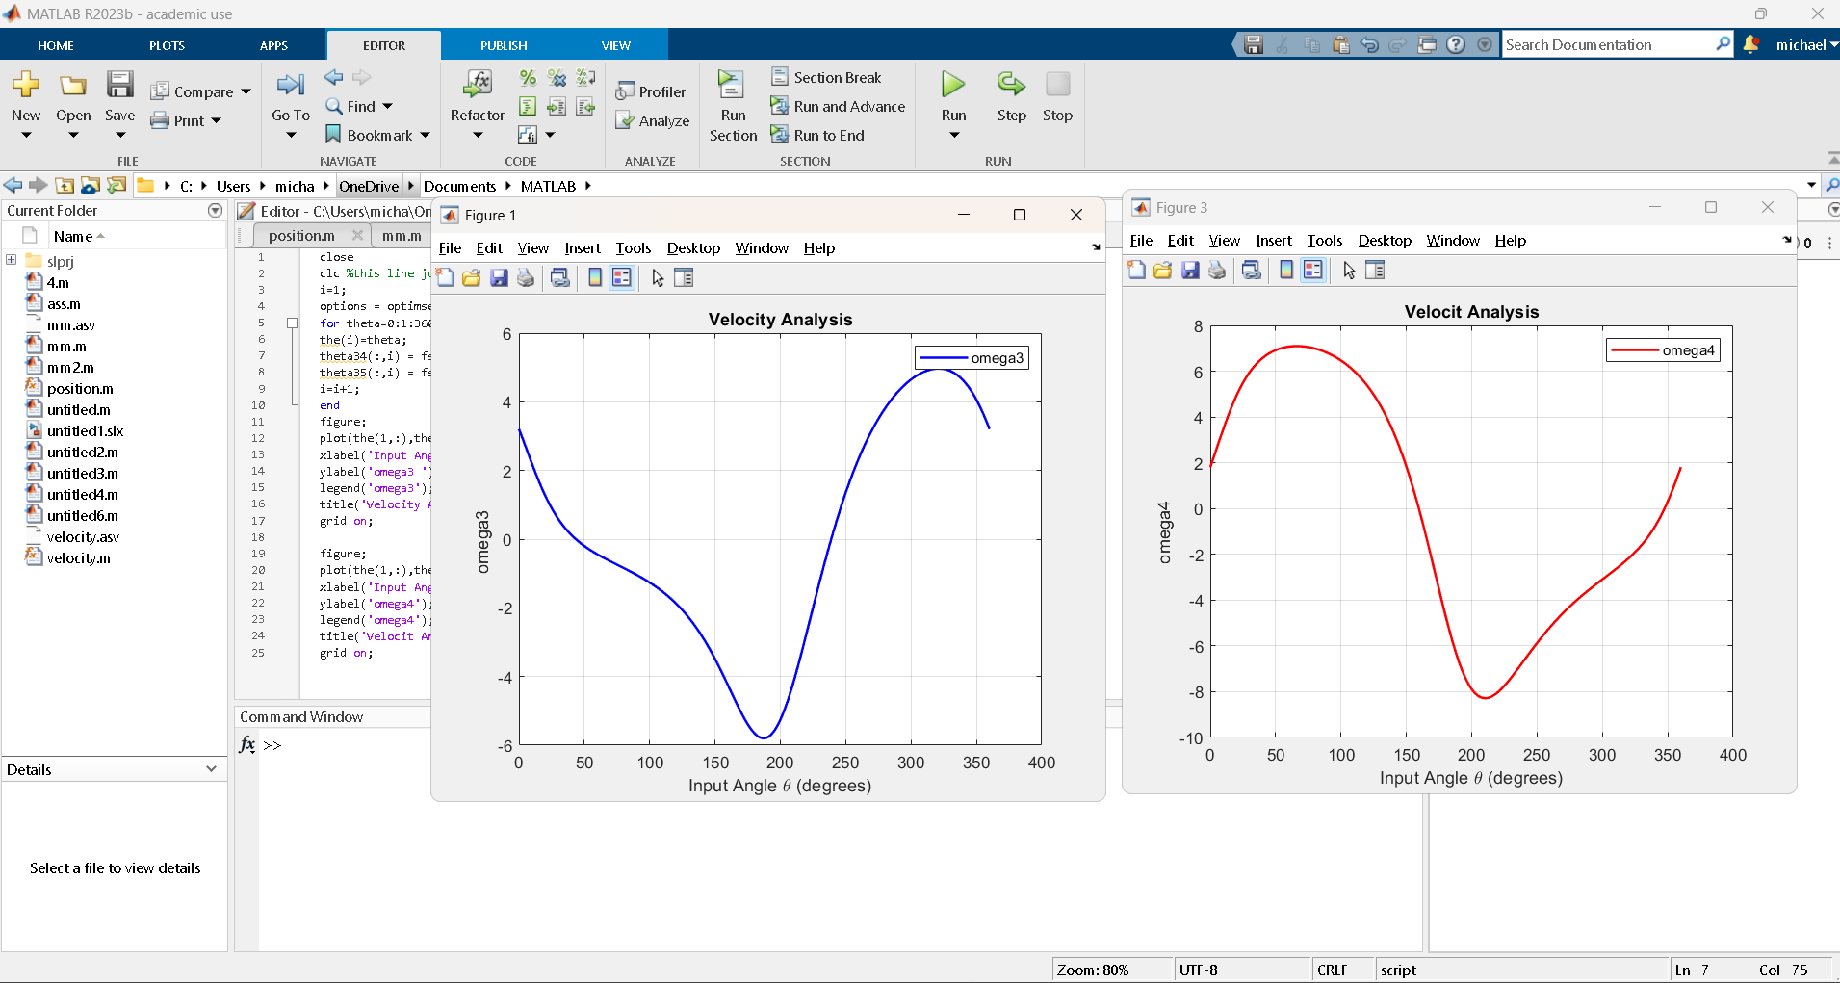

Acceleration:

Second. Slider crank :

 The kinematic equations using the analytical approach:

**MATLAB files graphs:**

Position:

Velocity:

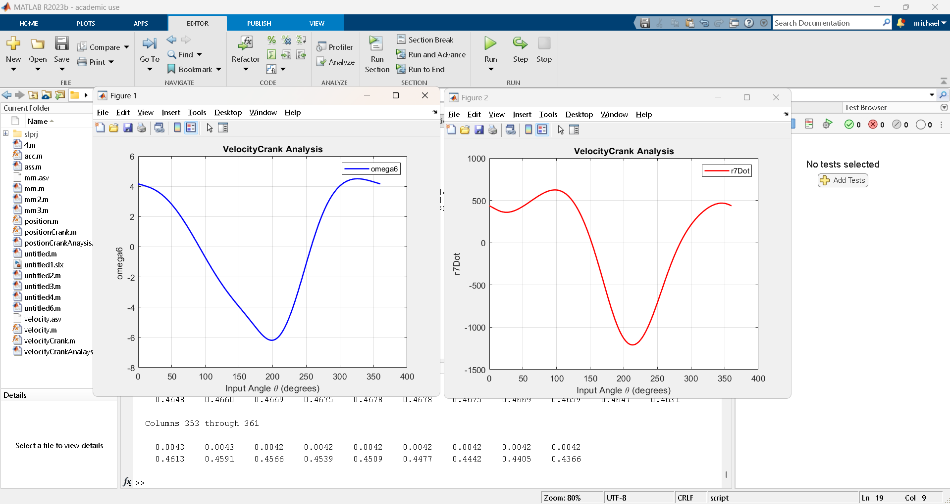

Acceleration:

**The velocity and acceleration diagrams at the chosen angle:**

Theta = 90 degree

Velocity of four bar mechanism:

Velocity of slider crank:

Acceleration of slider crank:

**Comparison between the values obtained from the graphical, analytical, and software at the same input angle:**

for velocity, there is a small difference between the graphical solution and software output

as the graphical was

omega3 = 1.1428 rad/s omega4 = 6.811 rad/s

for velocity crank, there is a small difference between the graphical solution and software output

as the graphical was

R7dot = 620 cm/s omega6 = 0.1714 rad/s

for acceleration, there is a little big difference between the graphical solution and software output

as the graphical was

alpha4 = 15.34 cm/s^2 alpha3 = 12.57 rad/s^2

for acceleration crank, there is a little big difference between the graphical solution and software output

as the graphical was

R7DoubleDot = 4 m/s^2 alpha6 = 18.2 rad/s^2

